DevOps

Setting name and email of the user.

Make a directory and change dir

Creating a file named “index.html” and opening in nano editor

Adding the file in staging area:

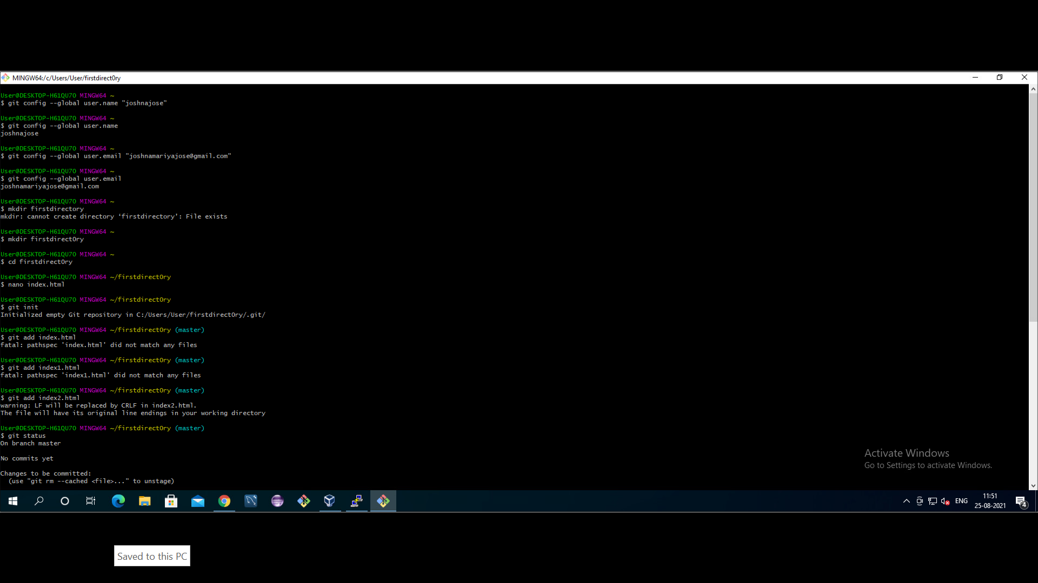

Git status to know the changes staged, which files are being tracked by git.

Adding files to github. git remote add origin <path of the github repo

Push the commits to remote location: git push -u origin master

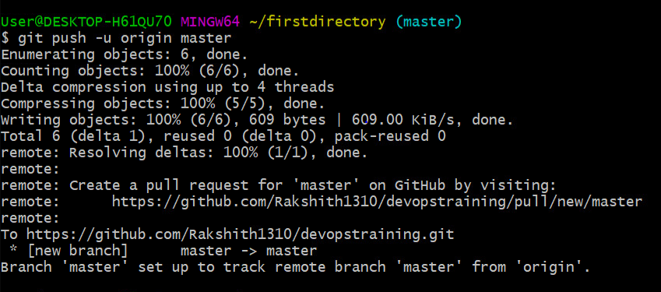

Creating new branch

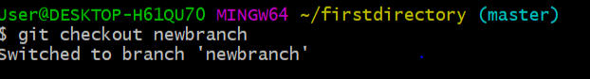

Viewing all branches

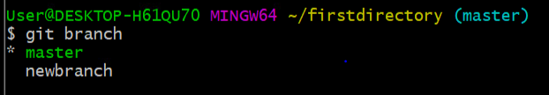

Viewing all branches including hidden ones

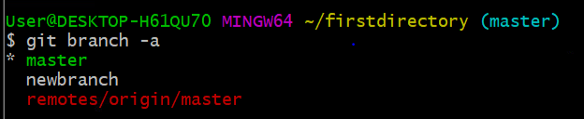

Deleting branches

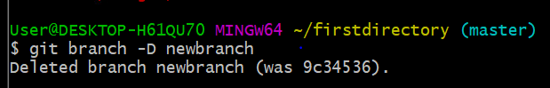

DOCKER

Installing docker in ubuntu:

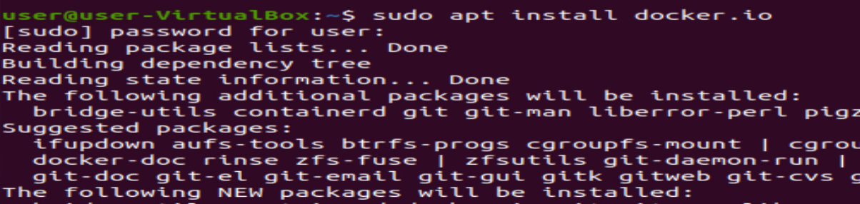

Checking version:



Displaying all images present in docker:

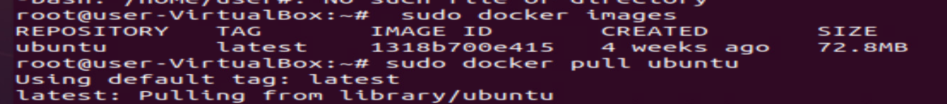

Taking everything from docker images:

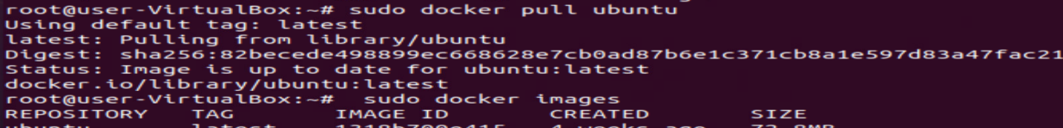

Displaying all docker images:

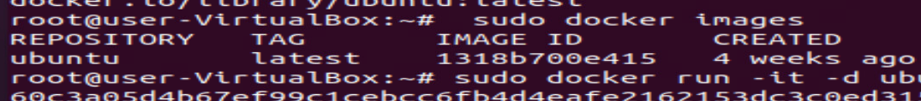

Creating container id for docker image:

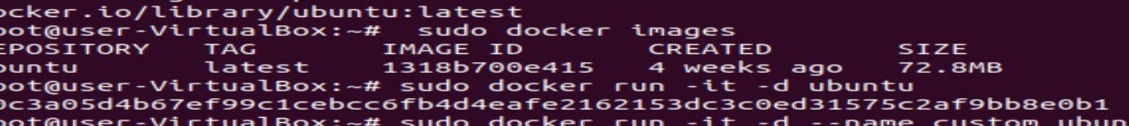

Creating custom docker image:

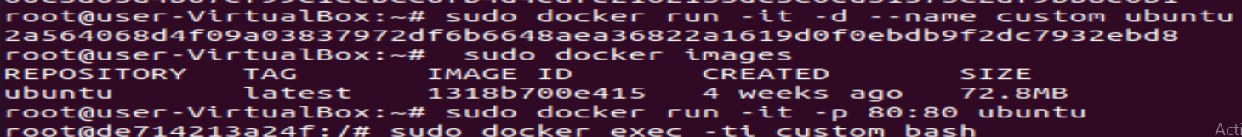

Displaying all images:

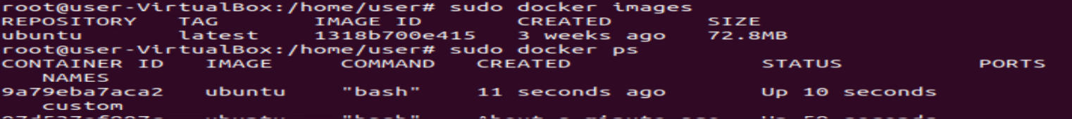

Align container port to localhost:



To get inside the container:



Exit from container:

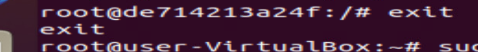

Install nginx:

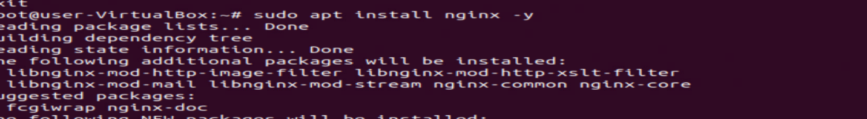

Checking active status of nginx:

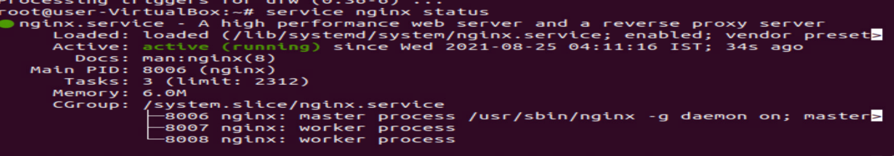

AWS

Creation of aws account, select ec2, select free one(OS), elect instance type- t2, which is free tier

Configure, add storage and changes to be made.

Kubernates

Create a dockervm, a master and two slave instances, and configure all of them with respect to putty gen and putty app.

Create instance, download key pair of instances (which would be .pem file).

Copy its ipv4 public address, open puttyGen browse pem file and save its private key (with same name as .pem file)

Open putty app, paste IPv4 address here, search ssh 🡪 auth 🡪 browse for ppk file (which created during puttyGen) 🡪 open. This opens cmd prompt.

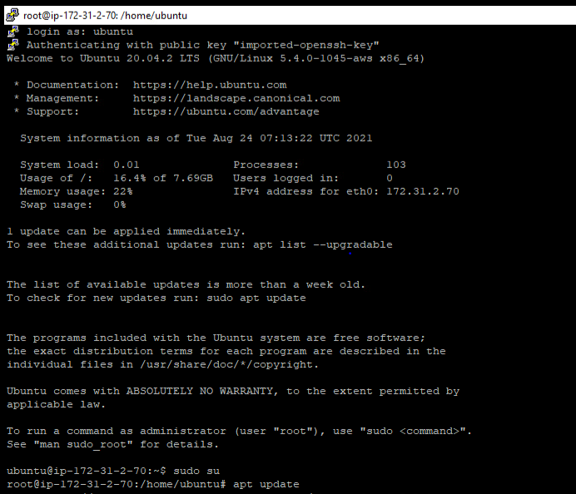Type ubuntu 🡪 sudo su 🡪 apt update

Install docker and Kubernetes (kubeadm, kubectl, kubelet) in all instances i.e., master&slaves.

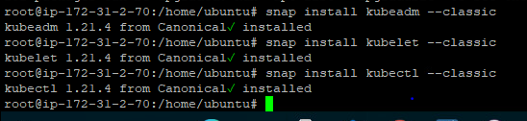

Jenkins

Create a Jenkins instance in aws. Use puttyGen and putty app as usual.

Open putty app, paste IPv4 address here, search ssh 🡪 auth 🡪 browse for ppk file (which created during puttyGen) 🡪 open. This opens cmd prompt.

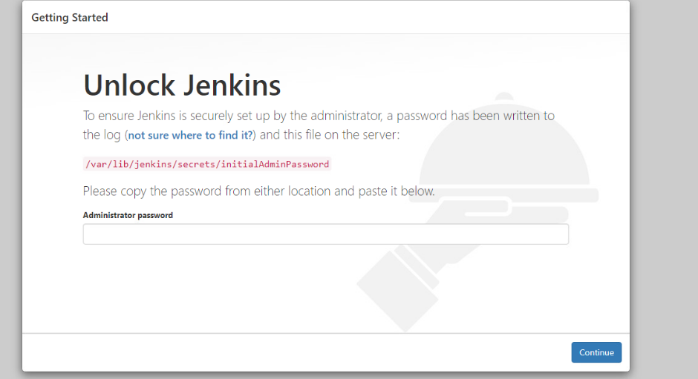

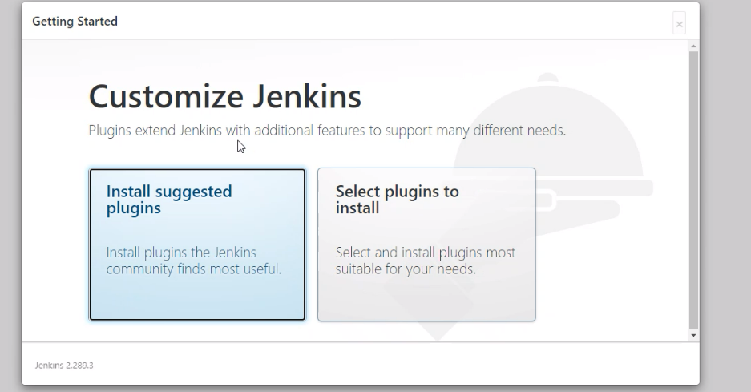

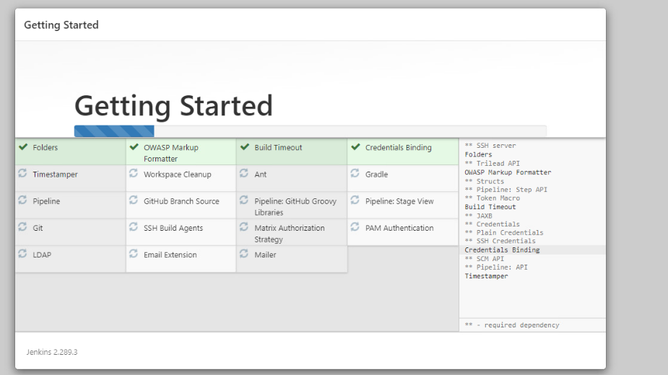

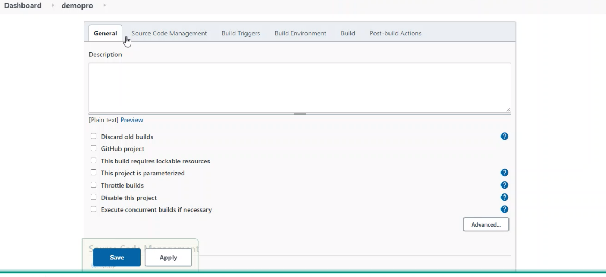

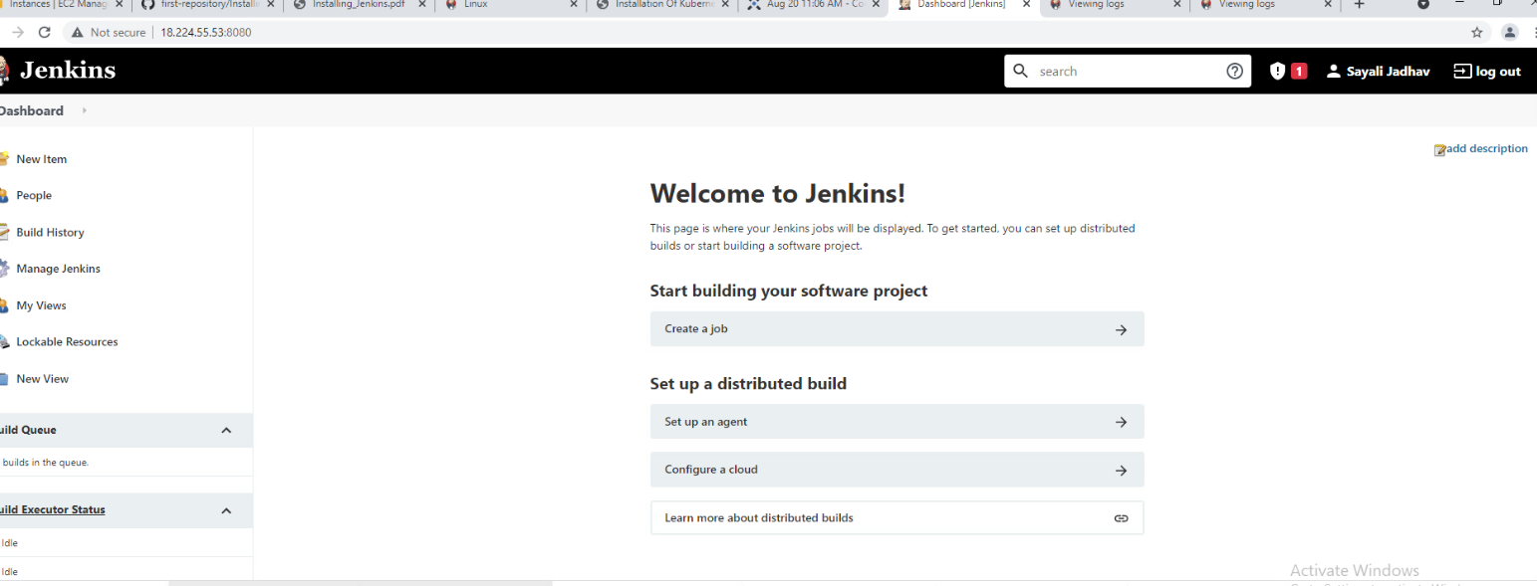

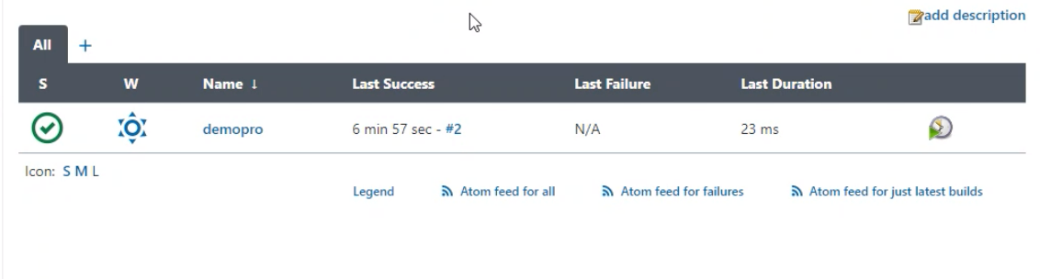

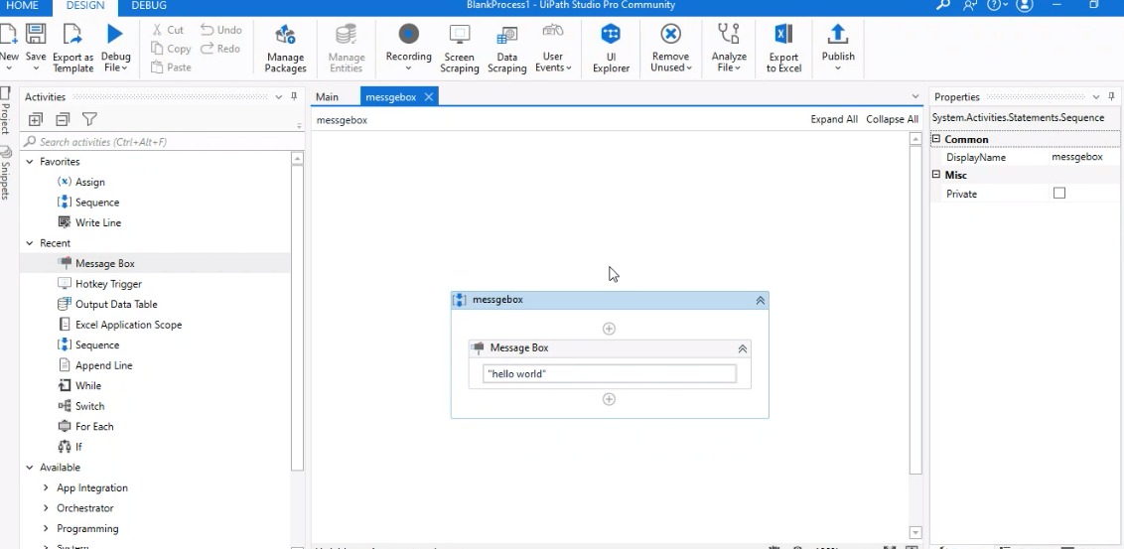

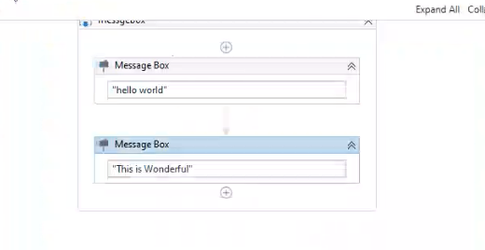

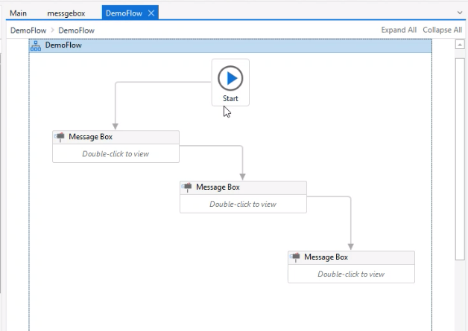

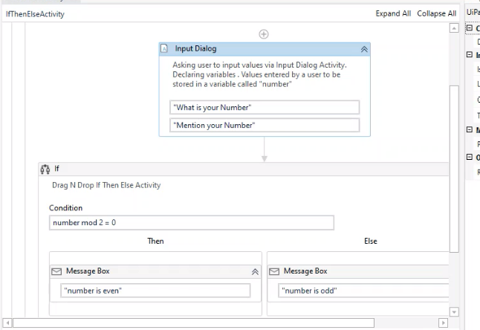

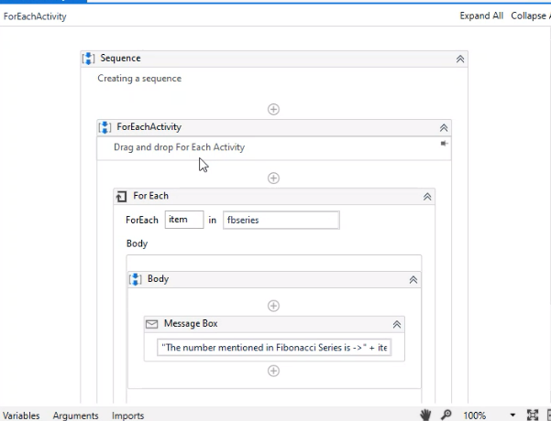

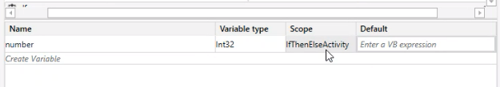

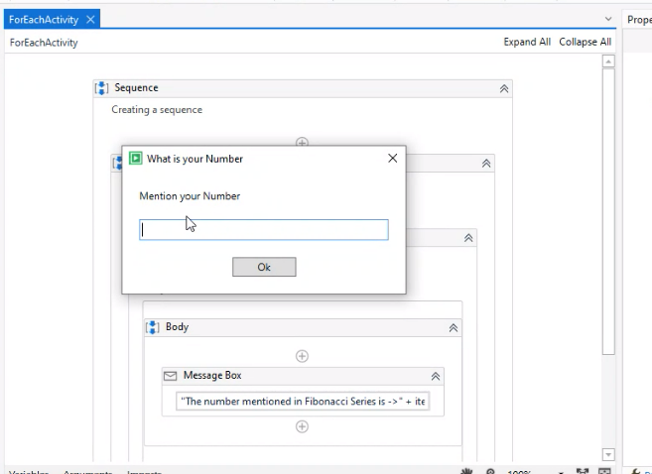

Install java on ubuntu.

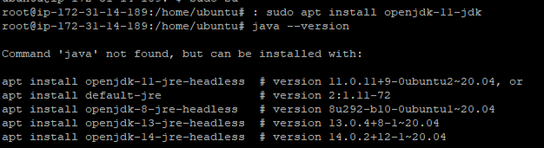

Add Jenkins repositories





Unlock Jenkins by knowing the IPv4 address of Jenkins instance.

We will get a link in the browser, prefix “cat” and then run the link to obtain password, paste it in the browser to open the dashboard.